C47/R47 Application note 018:
Keyboard Functions and Settings
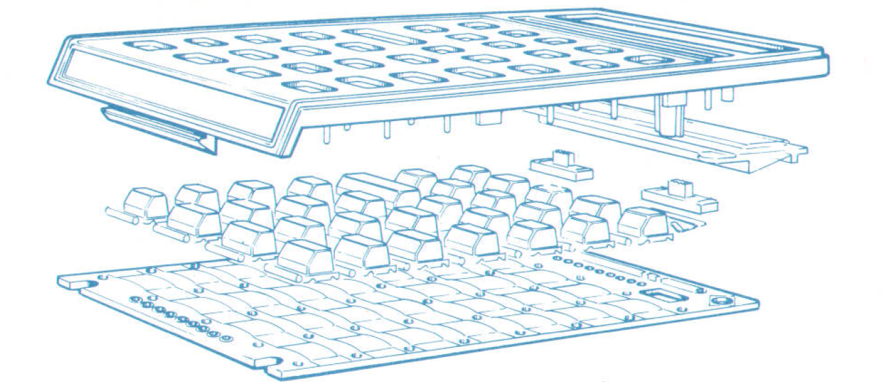

HP Woodstock keyboard design (HP Journal – November 1975)
Section 1: Overview 3
Section 2: Standard Keys functions and settings 5
The ENTER key 5
The Backspace key (←) 5
Key double press 5
Key long press 6
Key long press EXIT & BKSPC 6
Key long press Soft keys 6
Key long press - Normal Mode (NM) and Numeric Input Mode (NIM) 7
Key long press - Alpha Input Mode (AIM) and Equation Input Mode (EIM) 8
The Shift keys 8
C47 yellow shift key 8
R47 yellow and blue shift keys 8
Shift status display 9
The Up and Down arrow keys 10
Alpha entry mode selection with the shift, up and down keys 11
Section 3: Key assignments 12
Key assignments 12
Soft keys and user menus assignments 13
Assigning to soft keys 13
MyMenu pre-defined ribbons 13
Creating user menus 14
C47 Σ+ key and R47 Blank key 14
The C47 Σ+ key 14
The R47 Blank key 14
Removing assignments 15
Key assignments example 16

Summary
This chapter describes the keyboard logic and configuration mechanisms. It explains how key behaviour is defined across modes and how the available interaction mechanisms can be combined to adapt the keyboard for individual usage.
The keyboard follows some HP conventions and extends them through multiple functions, soft keys, and context-dependent behaviour. Shift keys, long press and double press actions provide alternative access paths to functions for ease of use and to reduce keystroke counts.
Key assignments are supported at several levels, including physical keys, soft keys, and menus. This extends the traditional USER mode and custom menu concepts, allowing functions, programs, variables, menus, and characters to be bound to keys as required. Limited Normal-mode key customisation (as opposed to USER-mode key customisation) is also supported for frequently used functions.

Revision | Date | Description
1.0 | 2026-01-23 | First publication.

Section 1: Overview

This document’s goal is not to describe each individual key function but rather to explain the keyboard logic and the different mechanisms implemented on the C47 and R47, and their configuration, allowing each user to set up the keyboard as needed.

The keyboard is the main way to interact with the calculator through the display. The C47 and R47 keyboard layouts and functions have been inspired by several HP calculators (in particular the HP-42S, HP-41C, or the HP-34C) and provide three functions per key and support many options and customisation possibilities.

The C47 keyboard layout leverages the HP-42S layout with identical primary function keys and many identical f-shifted keys to allow reusing the DM42/DM42n hardware with a simple overlay. As there is only one shift key, the g-shifted functions are accessed by pressing the shift key twice.

The R47 keyboard layout is an evolution of the C47 layout with the HP-42S layout compatibility constraint removed, thus implementing two shift keys, a yellow f-shift and a blue g-shift, as traditional HP calculators.

Both the C47 and the R47 support the HP-42S-style soft keys in addition to the standard keys. The soft keys are associated with soft menus displayed at the bottom part of the screen and each soft key can have three functions: primary, f-shifted, and g-shifted. The primary functions are displayed on the bottom line of the menu, just above the soft keys. The f-shifted functions are displayed on the line above the primary functions, and the g-shifted functions on the line above the f-shifted functions.

In addition to the standard functions accessed by directly pressing the key or prefixing it with a shift key, the C47 and R47 support a long press or double press mechanism which can replace the shift keys or provide access to different functions as described in the related sections below.

The C47 and R47 support user key assignment similar to the one introduced on the HP-41C, allowing a fully customisable keyboard in USER mode. They also leverage and extend the HP-42S custom menu, allowing the creation of new user custom menus or the customisation of some system menus.

And finally, both calculators support the customisation of one key in Normal mode (out of USER mode): the C47 Σ+ key and the R47 Blank key.

Figure 1: Key operation overview diagram

Section 2: Standard Keys functions and settings

The ENTER key
The ENTER key is the main characteristic of an RPN calculator; its function is to close entries and push entries onto the stack.
Traditionally, on HP calculators, ENTER does both: when entering a number, pressing ENTER will close the number entry in the X-register and duplicate it in the Y-register, pushing the content of the previous stack registers above the Y-register, ready for a new number entry in the X-register.
Lately, HP introduced a different ENTER working model where the two functions are separated: pressing ENTER when entering a number just closes the entry and places the number in the X-register, pushing the content of the previous stack registers above the X-register; then the duplication of the X-register is done when pressing ENTER out of entry mode. This is called Entry RPN or eRPN and is the mode selected by default on the C47 and R47.

The Backspace key (←)
The backspace key is used to clear digits during number entry (or characters during string entry or program steps in program entry mode), and when not in entry mode it clears the X-register as on traditional HP RPN calculators.
Change backspace to drop the X-register as on HP RPL calculators, by setting the flag ←DROP in the C47 MODE > CFLG menu or the R47 PREF > CFLG menu.
Note: when ←DROP is cleared, a double press on the backspace key will drop the X-register, but when ←DROP is set pressing twice on the backspace key will drop the X-register twice.

Key double press
A quick double press on some keys will lead to specific actions:
- double press on the backspace key (←) will drop the X-register by default (←DROP flag cleared in the CFLG menu)
- double press on a soft key will execute the associated g-shifted function by default (g.2TP flag set in the C47 MODE menu or the R47 PREF menu)
Note: This double press is blocked for the navigation keys in editing menus such as the ALPHA menu, where pressing twice an arrow key just executes it twice. This is indicated by a small stroke in the top right angle of the soft key primary label.

Key long press
Key long press was introduced on the HP-41C as a way to display the function name associated to a key, with a possibility to not execute it by keeping the key pressed until the function name is replaced by NULL. This is particularly useful in USER mode when a function assigned to a key is different from the standard function printed on the key or on the bezel.
On the C47/R47, this has been extended so that long press on some keys can be used as a shortcut to access shifted functions or additional functions: during a long press, a sequence of functions is displayed on the top left of the screen. Releasing the key will execute the function displayed:

Key long press EXIT & BKSPC
- Long press on EXIT will show the following context sensitive sequences
 | R47 | C47
Normal mode (NM) | EXIT – SNAP – CLRMOD – NOP | EXIT – MyMenu – CLRMOD – NOP
‍Number entry (NIM) | EXIT – SNAP – CLRMOD – NOP | EXIT – MyMenu – CLRMOD – NOP
Program Edit (PEM) | EXIT – P.FN – SNAP – CLRMOD – NOP | EXIT – P.FN – MyMenu – CLRMOD – NOP
Alpha Edit (AIM)‍ | EXIT – MyAlpha – CLRMOD – NOP | EXIT – MyAlpha – CLRMOD – NOP
‍Equation Edit (EIM) | EXIT – MyAlpha – CLRMOD – NOP | EXIT – MyAlpha – CLRMOD – NOP

- Long press on the backspace key (←) will show the following context-sensitive sequences: providing a shortcut access to the various clear options (CLN), (CLA), clear stack function (CLSTK) and the EDIT function.
 | R47/C47 | Detail
Normal mode (NM) | CLX* – CLSTK – EDIT – NOP | CLSTK: Clear stack←
‍Number entry (NIM) entry (NIM) | BKSPC – CLN – NOP | CLN: Clear the numeric input buffer
Program Edit (PEM) | BKSPC – EDIT – NOP | EDIT: Edit the current text
Alpha Edit (AIM)‍ | BKSPC – CLA – EDIT – NOP | CLA: Clear the alpha input buffer
‍Equation Edit (EIM) | BKSPC – CLA – EDIT – NOP | CLA: Clear the equation (alpha) input buffer
*CLX is replaced by DROPx when the flag ←DROP is set

Key long press Soft keys
Normal mode (NM) and Numeric Input Mode (NIM):
- Long press on a soft key; the key will depend on the settings: F.14, F.124 and F.1234:
  - F.14 set: the sequence will be: primary_function – NOP
  - F.124 set: the sequence will be: primary_function – f-shifted function – NOP
(this is the default setting)
  - F.1234 set: the sequence will be: primary_function – f-shifted function – g-shifted function – NOP

Key long press - Normal Mode (NM) and Numeric Input Mode (NIM)
- Long press on a math key (the two rows below the function keys, plus x<>y and +/- on the C47 or x<>y, CHS and XEQ on the R47) will depend on the settings M.14, M.124 and M.1234³:
  - M.14 set: the sequence will be: primary_function – NOP
(with two exceptions: the XEQ sequence is: XEQ – α – NOP, the DRG sequence is: DRG – USER – NOP)
  - M.124 set: the sequence will be: primary_function – f-shifted function – NOP
  - M.1234 set: the sequence will be: primary_function – f-shifted function – g-shifted function – NOP (this is the default setting)
- Long press on ENTER in Normal mode NM and number entry NIM mode, the usual M.14, M.124 and M.1234, will determine the sequence, see the long press tables above.
- Long press on a number entry key (0-9 digits, . (dot), E or EEX) has no effect
- Long press on an operator key, an arrow key or the R/S key will just lead to NOP
- Long press on a Shift key is described in the next section

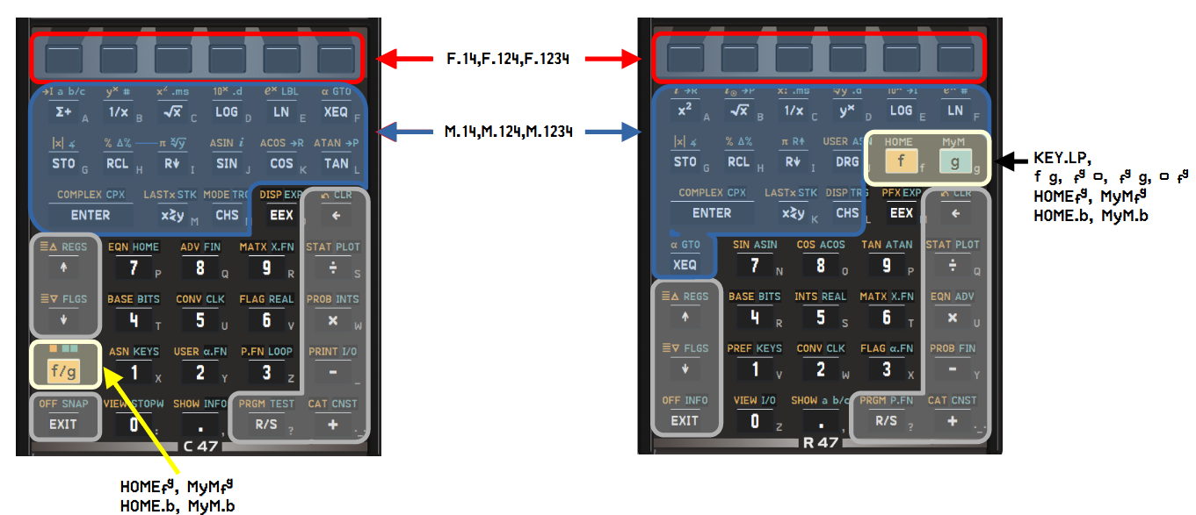Figure 2: Keys with long press functions and the settings controlling their behaviour.

Key long press - Alpha Input Mode (AIM) and Equation Input Mode (EIM)
- Long press on ENTER within AIM or EIM modes will produce the sequence EDIT – CR – NOP.
CR produces the character ↵ used with AVIEW, to add a TI comment.
- Long press on a key with a white alpha letter A-Z also some punctuation, will initiate a single delay and cause the key-top label to be entered into the string, eg. pressing a digit with first produce the white alpha label, then time-out to the actual digit.
This shortcut to get to the digits and operators while entering formulas in EIM is very useful.
- Long press on a Shift key is described in the next section

The Shift keys

C47 yellow shift key
As with the HP-42S, the C47 has only one yellow shift key. On the C47, it acts as a combined f/g key: a single press on the yellow shift key provides access to the f-shifted functions, and a double press provides access to the g-shifted functions.
The C47 shift key also provides access to a third function, either with a triple press or with the long press sequence f – g – <function>: by default it is the HOME menu, but it can be configured to be MyMenu or can be disabled, depending on the settings of HOME⧱, MyM⧱, HOME.b and MyM.b in the C47 MODE menu:

R47 yellow and blue shift keys
The R47 has two shift keys, a yellow f key providing access to the f-shifted functions, and a blue g key providing access to the g-shifted functions.
The R47 shift keys can also provide access to a third function with a long press: by default it is the HOME menu for the yellow shift key, and MyMenu for the blue shift key (corresponding the CUST name on the bezel). The long press access is controlled by KEY.LP in the R47 PREF menu.
The R47 shift keys can also be configured in a different way than the standard f and g shift keys: one key can be configured as the C47 f/g shift key, and another key can be configured as a blank key fully configurable (see details in the related section). The R47 shift keys configuration is controlled by 4 options in the KEYS menu according to the following table:

Shift status display
The shift status determines the function executed by the next key press and is indicated on the top left of the display and depends on the status of the flag SBshfR:
- SBshfR cleared (default):
  - f or g letter on the left of the status bar when the time (SBtime) and the week of year (SBwoy) display is off:
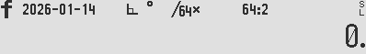
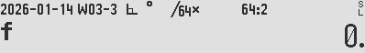
  - f or g letter on the left of the T-register display line, below the status bar, when the time (SBtime) or the week of year (SBwoy) display is on:
- SBshfR set:
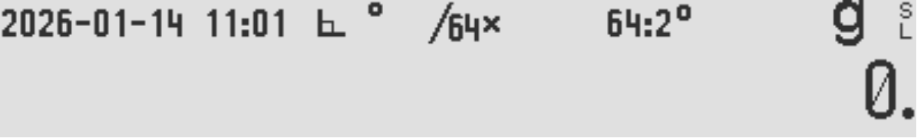
  - f or g letter on the right of the status bar :

The shift status can also be reflected in the display of the current menu where either a line is drawn under the f- or the g- menu row when f or g is pressed, or the corresponding line is highlighted.
This is controlled by the flags fg.LIM, fg.FULL and fg.GR:
 | fg.FULL set | fg.LIM set | fg.FULL cleared  fg.LIM cleared
fg.GR cleared | Show all f- and g-lines (default) | Show lines for non empty-rows only | Don’t show f- and g-lines
fg.GR set | Highlight all f- and g-menu rows | Highlight non empty-rows only | Don’t highlight f- or g-menu rows

Examples:
- fg.GR cleared, fg.FULL set and f-shift pressed :
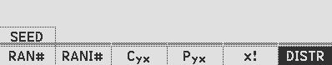
- fg.GR cleared, fg.FULL set and g-shift pressed :
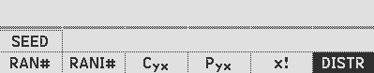

- fg.GR set, fg.LIM set and f-shift pressed :
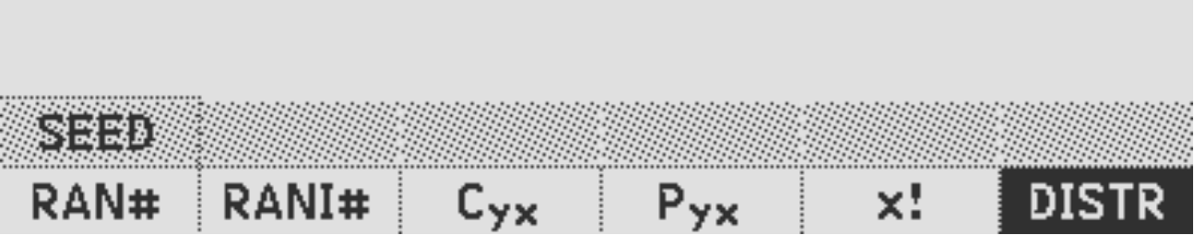
- fg.GR set, fg.LIM set and g-shift pressed :
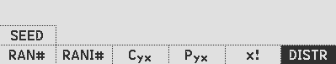

The Up and Down arrow keys
The Up (↑) and Down (↓) arrows have different functions depending on the context :
- When a multi-page menu or catalog is open, users navigate up or down by one page (in menus) or one line (in catalogs).
- in Alpha entry they move to the beginning (↑) or end (↓) of the current string
- in normal mode ↑ does BST and ↓ does SST
The Shift Up (⇌↑) and Shift Down (⇌↓) arrows have different functions depending on the context :
- When a catalog is in Alpha Search Mode (ASM) or during alpha input, users select the alpha entry type (uppercase, lowercase, or numeric) as shown in the figure below
- otherwise ⇌↑ does BST and ⇌↓ does SST

Alpha entry mode selection with the shift, up and down keys
In addition to the flags CAPS, NUM and ^{SUP}_{SUB} available in the ALPHA and TamAlpha menus, the selection of Upper case, Lower case, Numeric, Superscript or Subscript alpha entry mode can be done by a combination of the f and g shift keys and the Up and Down arrows as described in the following figure where solid boxes indicate a persistent mode and dotted boxes indicate a transient mode applicable to the next character only:
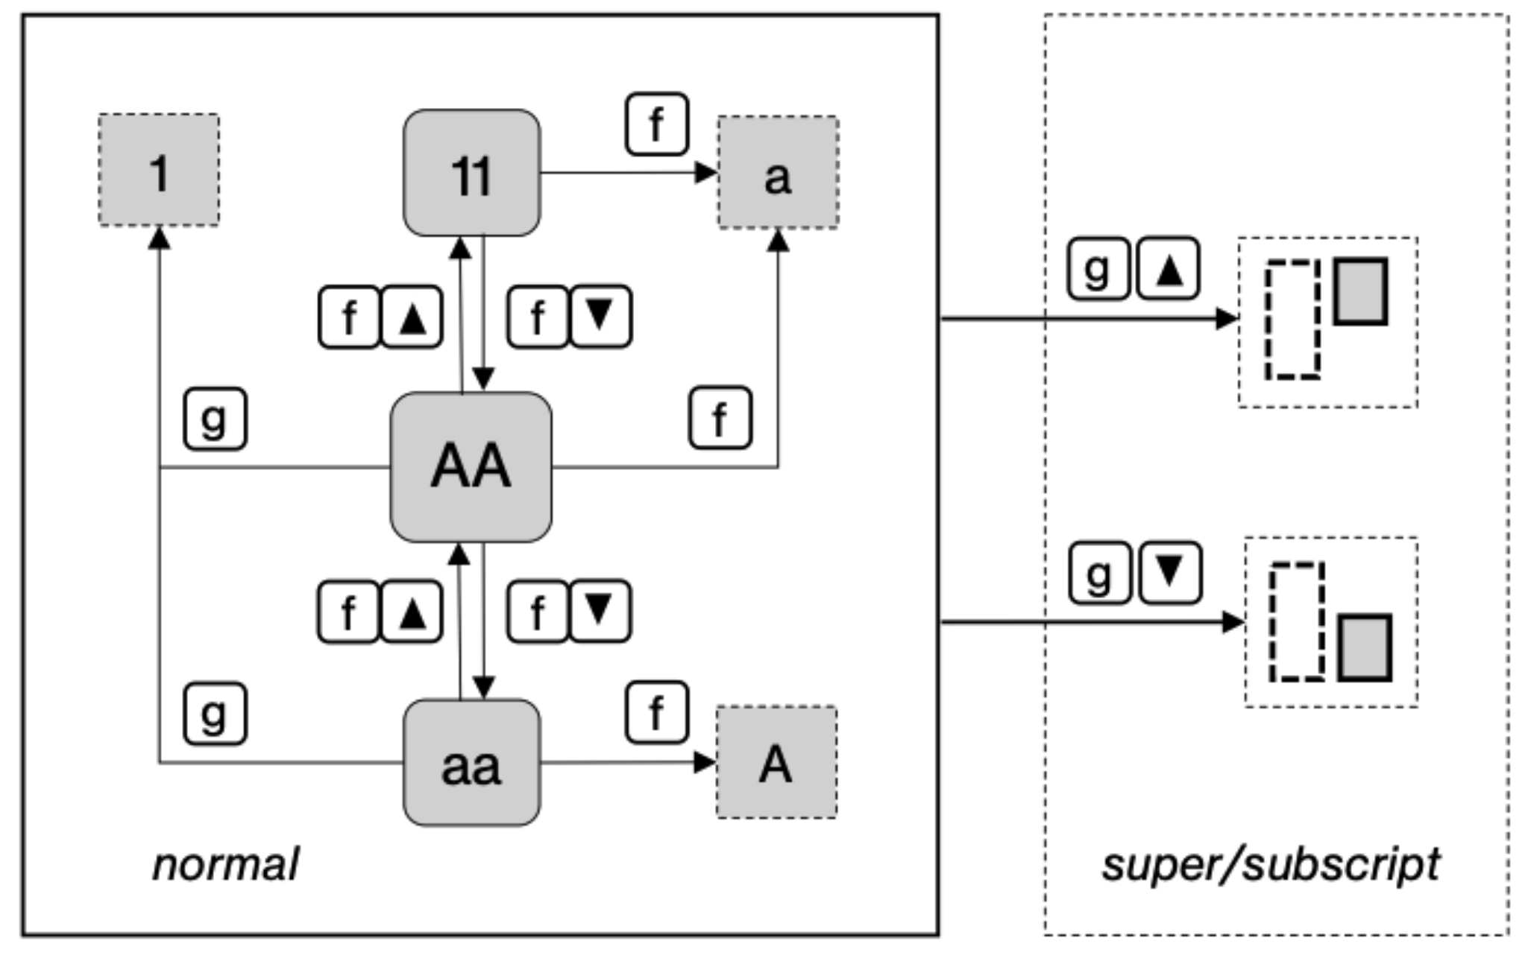

The current Alpha entry mode is indicated in the status bar by a single letter :
A | Upper case | ^{A} | Upper case superscript | _{A} | Upper case subscript
a | Lower case | ª | Lower case superscript | _{a} | Lower case subscript
N | Numeric | ^{N} | Numeric superscript | _{N} | Numeric subscript

The Greek letters and International characters catalogs in the ALPHA and TamAlpha menus will follow the Upper/Lower case status :
- Upper case : Α...Ω and αINTL
- Lower case : α...ω and αintl
When the Greek letters and International characters catalogs are opened, the Up and Down keys are used for both navigating in the catalogs and changing the case :
- Α...Ω or αINTL opened :
  - Up moves to next catalog line while staying in upper case
  - Down changes to the lower case catalog ( α...ω or αintl)
- α...ω or αintl opened :
  - Up changes to the upper case catalog ( Α...Ω or αINTL)
  - Down moves to previous catalog line while staying in lower case

Section 3: Key assignments

The USER mode with the capability of assigning functions or programs to specific keys has been introduced on the HP-41C. The HP-42S replaced this USER mode by a CUSTOM menu where the soft keys could be assigned specific functions, programs, or variables.
The C47 and R47 support and extend both ways of providing user keys. This is done via the ASN (ASSIGN) function as described below, and allows assignment of functions, programs, variables as well as menus or characters to specific keys in USER mode, to some of the system menus, and to user-created menus.

Note: ASN is not programmable, so assignments cannot be done programmatically.

Key assignments
To assign a specific item (function, program, variable, menu or character) to a key the generic mechanism is:
ASN <item to assign> <destination key>
ASN: on f-1 for the C47 and g-DRG for the R47. ASN is not available on a key during alpha entry, it is in the ALPHA menu for alpha character assignments. ASN is also in the KEYS menu.
- <item to assign>: can be selected directly on the keyboard (via a key or a soft key), selected from a menu, or by entering its name in alpha. Pressing a menu on the keyboard will actually open the menu. To assign a menu name, it must be selected from CAT > MENUS. Similarly, to assign a program or variable, it must be selected from CAT > PROGS or CAT > VARS. Characters can only be assigned in Alpha mode by selecting them on the keyboard or in one of the alpha menus. Pressing ENTER at this stage will assign NULL to the destination key, restoring its default function.

- <destination key>: press the key where the item should be assigned. This can be a primary key, an f-shifted key or a g-shifted key. To assign an item to a shift key long press function, just long press the shift key.
The existing key assignments can be visualised in KEYS > KEYMAP on the different keyboard planes (unshifted, f-shift, g-shift, alpha unshifted, alpha f-shift, alpha g-shift). Long press assignments are visible on the g-shift plane.
Once the item is assigned to a key, pressing this key in USER mode will execute the item:
- function: the function will be executed
- program: while only the program name is visible in KEYMAP or in a soft menu, the action executed is XEQ ‘program’
- variable: while only the variable name is visible in KEYMAP or in a soft menu, the action executed is RCL ‘variable’
- menu: the assigned menu will be opened
- character: in alpha input mode the character will be inserted at the cursor location
Some specific function keys which are used in the assignment sequence need to be selected by their name to be assigned to a new location or as a destination key: ENTER, USER, EXIT, UP, DOWN and BKSPC.
The only keys that cannot be assigned to are the shift keys (f/g, f and g) and the α key (f-XEQ), so if you end up stuck in USER mode after re-assigning the USER key, there is always an escape path with f-α as USER is present in the ALPHA menu.

Soft keys and user menus assignments

Assigning to soft keys
Generally system menus are fixed and cannot be modified, however there are 4 system menus that can be customised by assigning specific items to their soft keys :
- HOME
Important! Once set with user soft keys, user menus will not change when new features are added in new firmware. KEYS RESETS Myα.R, MyM.R, HOME.R and PFN.R will reset the content to default.
- MyMenu
- Myα
- P.FN
HOME, MyMenu and P.FN have default functions already populated while Myα is empty, but any soft key of these 4 menus can be assigned a different item.
Assigning a specific item (function, program, variable, menu or character) to a soft key follows the generic mechanism presented above:
ASN <item to assign> <destination key>
where the <destination key> is a soft key of the menu displayed on the screen.
It is recommended before calling ASN to bring the destination menu on the screen so that after selecting the item to assign, if necessary, the destination menu can be easily brought back on the screen with EXIT, before pressing the destination key.
Note that after selecting the item to assign, two useful shortcuts are available:
- pressing f USER will bring back MyMenu, useful when assigning to MyMenu.
- Long pressing EXIT at this point, cycles the three writable menus MyMenu, HOME and P.FN which can be called up.

After the selection of the item to assign, a valid destination soft key is indicated by the ‘tiled’ view, ie. nails on the 4 corners of the soft key label.
Note : soft key assignments are independent of the USER mode.

MyMenu pre-defined ribbons
A set of pre-defined functions for the primary soft keys of MyMenu is available in the KEYS > RIBBONS menu. The ribbon collection attempts to provide frequently used groups of keys ready for instant replacement.
Each ribbon will redefine the primary function line of MyMenu for a different usage, meaning that if you use ribbons, prior assignments to F1...F6 will be lost. See the RIBBONS menu for the detailed definition of the different ribbons.

Creating user menus
In addition to the 4 assignable system menus, it is possible to create user menus and to assign any item to these menus.
User menus can contain up to 18 items (3 rows of 6 soft keys) in a single menu page.
The creation of a user menu is done by the following sequence :
ASN USER <user_menu_name>
- <user_menu_name> should not be the name of an existing system or user menu
Once a user menu is created it is available in CAT > MENUS and can be selected to assign items to the different soft keys.
A user menu can be deleted with g CLR > DELETE > DELITM > MENUS > <menu>

C47 Σ+ key and R47 Blank key
The C47 and R47 also support the customisation of one key in Normal mode (out of USER mode): the C47 Σ+ key and the R47 Blank key (one of the shift keys).

The C47 Σ+ key
The C47 allows the customisation of the primary function of the Σ+ key in Normal mode. This is done by selecting a function in the menu KEYS > Σ+ KEY.
The default function for this key is Σ+ and a set of alternate functions is available in this menu. If the standard options are not sufficient U→N will transfer any primary assignment done for the Σ+ key in USER mode to the Σ+ key in Normal mode.
See the Σ+ KEY menu for the definition of the different options.

The R47 Blank key
The R47 allows also the customisation of one key in Normal mode: one of the shift keys. This is done by changing either the yellow or blue shift to the ⧱ shift function and defining the other shift key as a blank key in the R47 KEYS menu.
Once either shift key has been defined as blank key, the primary function for this key can be selected in KEYS > ▢ KEY. If the standard options are not sufficient U→N will transfer any primary assignment done for the blank key in USER mode to the blank key in Normal mode.
[f-shifted and g-shifted functions can be also assigned to the Blank key in normal mode by transferring them by U→N once assigned in USER mode. – This is not yet implemented]
Note : when a shift key is defined as a Blank key, long press is not supported and instead it supports only primary, f-shifted and g-shifted access as a standard key.
See the ▢ KEY menu for the definition of the different options.

Removing assignments
A key or soft key assignment is removed by assigning NULL to the key with ASN ENTER <destination key>
All key assignments on the keyboard can be removed by KEYS > RESETS > KEYS.R (this doesn’t remove soft key assignments in menus).
When a program, variable or user menu is deleted, all assignments of this program, variable or user menu are also deleted from keys on the keyboard or soft keys in menus.

Key assignments example
Here is a simple example showing the different types of assignments.
First start with entering the following program with the 3 routines : →UNIT to set the UNIT display mode and ↑UNIT and ↓UNIT to increase or decrease the unit factor (the arrows →↑↓ are in the second page of the αMISC catalog):
0001: LBL ‘→UNIT’
0002: UNIT 04
0003: RTN

0004: LBL ‘↑UNIT’
0005: 1.×⑽³
0006: ×
0007: RTN

0008: LBL ‘↓UNIT’
0009: 1.×⑽³
0010: ÷
0011: END
Assignments to keys
Let us assign →UNIT to the 1/x key, ↑UNIT to the Up arrow key and ↓UNIT to the down arrow key :
ASN f CAT PROGS →UNIT 1/x
ASN PROGS ↑UNIT f α ‘UP’ ENTER
ASN PROGS ↓UNIT f α ‘DOWN’ ENTER
KEYS > KEYMAP shows the assignments done to the USER primary key functions :
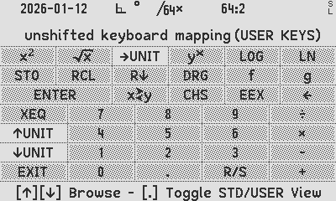
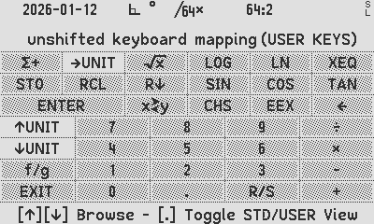

C47 KEYMAP R47 KEYMAP
Press f USER to select the USER mode, enter a number and press 1/x , this will execute →UNIT and set the UNIT mode.
Now pressing the Up arrow will change the number to the next upper unit and pressing the Down arrow will change the number to the next lower unit.

Assignments to a User Menu
Instead of assigning the different programs to standard keys, it may be preferable to create a user menu and assign them to this user menu.
First delete your current key assignments with KEYS > RESETS > KEYS.R. Verify the assignments are gone in KEYMAP.
Let us create a user menu named TESTMNU :
ASN USER ‘TESTMNU’
Open this newly created menu :
f CAT MENUS T TESTMNU
Assign the different programs to the menu softkeys :
ASN f CAT PROGS →UNIT EXIT F1
ASN f CAT PROGS ↑UNIT EXIT F5
ASN f CAT PROGS ↓UNIT EXIT F6
You should end up with the following menu :
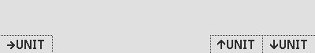

Assign this user menu to a long press shift function :
ASN f CAT MENUS T TESTMNU long_press_on_Yellow_Shift
This will replace in USER mode the default HOME menu by TESTMNU, this is visible in KEYS > KEYMAP on the g-shift plane where the long press assignments are shown :
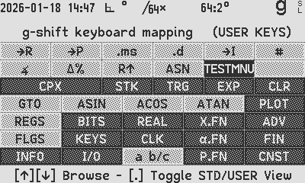
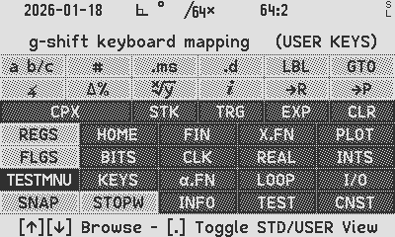

C47 KEYMAP R47 KEYMAP
In USER mode, a long press on the Yellow Shift key will open the assigned TESTMNU.

Assignments to the C47 Σ+ key
If USER mode is often used it could be interesting to assign it to a primary key that could also be accessed in normal mode, this is possible with the C47 Σ+ key.
In KEYS > Σ+ KEY, select ⇢ USER this assigns the USER function to the Σ+ key in normal mode.
To make this key a USER mode toggle key, the USER function should also be assigned in USER mode:
Press the Σ+ key to set USER mode, then ASN f α ‘USER’ ENTER Σ+
Now pressing the Σ+ key will toggle between normal and USER mode.
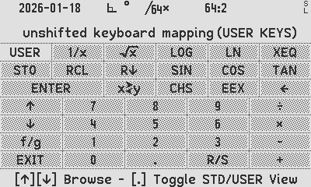
Instead of the predefined USER function the Σ+ key can be used to directly call the user menu TESTMNU.
Ensure USER mode is selected, then ASN f CAT MENUS T TESTMNU Σ+ will assign TESTMNU to the Σ+ key in USER mode. Once done this assignment can be transferred to the normal mode with KEYS > Σ+ KEY > U→N
The default Σ+ key function in normal mode is restored either by KEYS > RESETS > KEYS.R which clears all keys assignments, or by selecting ⇢ Σ+ in KEYS > Σ+ KEY.
Assignments to the R47 Blank key
If USER mode is often used it could be interesting to assign it to a primary key that could also be accessed in normal mode, this is possible with the R47 Blank key.
First one of the R47 shift key needs to be defined as a blank key. Let say the blue shift key will be the blank key and the yellow shift key will be the confined f/g shift (it could also be the opposite).
This is done with KEYS > ⧱ ▢
Now, in KEYS > ▢ KEY, select ⇢ USER this assigns the USER function to the Blue shift key in normal mode.
To make this key a USER mode toggle key, the USER function should also be assigned in USER mode:
Press the Blue shift key to set USER mode, then ASN f α ‘USER’ ENTER Blue_shift
Now pressing the Blue shift key will toggle between normal and USER mode.
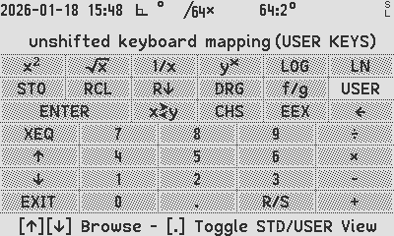
Instead of the predefined USER function the Blank key can be used to directly call the user menu TESTMNU.
Ensure USER mode is selected, then ASN f CAT MENUS T TESTMNU Blue_shift will assign TESTMNU to the Blue shift key in USER mode. Once done this assignment can be transferred to the normal mode with KEYS > ▢ KEY > U→N
The default Blank key function in normal mode is restored either by KEYS > RESETS > KEYS.R which clears all keys assignments, or by selecting ⇢ nil in KEYS > ▢ KEY.

Authors Didier Lachieze & Jaco Mostert
Copyright (C) 2026 The C47 Development Team. Permission is granted to copy, distribute and/or modify this document under the terms of the GNU Free Documentation License, Version 1.3 or any later version published by the Free Software Foundation; with no Invariant Sections, no Front-Cover Texts, and no Back-Cover Texts. A copy of the license can be downloaded from gnu.org.

The delay between two key press to get them recognised as a double press can vary but is generally below 150ms. When a function key is pressed the primary function is only executed 150ms after releasing the function key, unless a second press occurs on the same key during this delay in which case the g-shifted function is executed. For the backspace key the primary function is always executed when the key is released, and if it is pressed a second time within 150ms and ←DROP is cleared then DROPx is executed.
In the C47 MODE menu or the R47 PREF menu.
M.14 is similar to the HP-41C long press, and these two exceptions provide quick access to USER and ALPHA which are primary keys on the HP-41C.
A smaller f or g is displayed if the T-line content doesn’t allow for the full size f or g
As the menu name has the maximum number of characters (7) the ASN instruction is completed automatically once the last character is entered.
Pressing the letter T in the MENUS catalog will move to the names starting with T.
F1, F5 and F6 means pressing the corresponding function key numbered from left to right.
The Σ+ assignment needs to be done in USER mode, because in normal mode this key is now the USER key.
The blank key assignment needs to be done in USER mode, because in normal mode this key is now the USER key.
With the Blue shift configured as a blank key, access to the g prefix is done by pressing twice the yellow shift key (f/g).

